What is JavaEE Servlet Session handling?
Session handling provides a way to identify a user across more than one page request or visit to a Web site and to store information about that user.
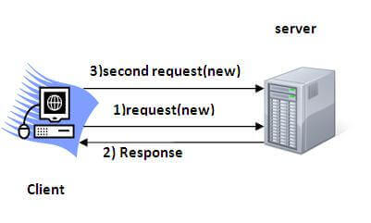
There are four techniques used in Session tracking:
- Cookies
- Hidden Form Field
- URL Rewriting
- HttpSession

